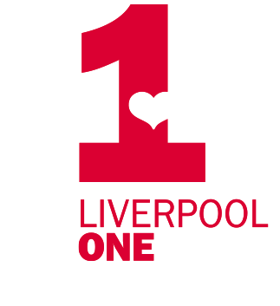
Artist Commission
for Liverpool ONE Pianos

Liverpool ONE is running its much-loved piano festival, Tickle the Ivories, this summer celebrating 15 years of the event.

We’re inviting artists to design one of 7 pianos which will be placed in prominent locations around the estate.

The theme this year is The Power of Music.

Music brings people together, connects cultures, and sparks memories. It can also help to heal trauma, express what words can’t, and marks life’s most memorable moments. Music is at the heart of some of the most meaningful social interactions, from raising money and awareness for charitable causes to fuelling creativity and innovation, music is a powerful tool that enhances lives. We would like artists to interpret the theme in any way they can relate.

Few local people represent the Power of Music more than Brad Kella. Coming through early adversity in Bootle, being fostered and ending up living on the streets – he went on to win Channel 4’s national televised talent show, The Piano. Brad played on Liverpool ONE’s Tickle the Ivories pianos before rising to fame and we were honoured to welcomed him back to Liverpool ONE to perform as part of our Christmas celebrations. We would like to celebrate Brad Kella as part of the ‘Power of Music’ theme by selecting an artist to design a piano dedicated to him.

We’re looking for:
- 1 design celebrating Brad Kella
- 6 designs by 6 different artists following the theme The Power of Music

You can submit one or more designs, one for Brad Kella and one linked to the Power of Music. We will select 7 different artists to design a piano each.

Proposed fee - £600 per piano

Submissions

Please send a sketch/mock up and description of your proposed design idea along with photos/graphics showing a selection of your past work if you have not worked with Liverpool ONE before, to melody.beard@liverpool-one.com

Timescale

Please submit an initial proposal by: 9am on Monday 19 May 2025

Artists appointed: Friday 23 May 2025

Deadline for final artwork submissions: 9am on Monday 9 June 2025
Artwork

- The selected artists will be supplied with a template like the one below for a specific piano, in Adobe Illustrator format. You should create and set up your design to print on this template, which is 10% of actual size.
- Your artwork will be printed and vinyled onto the body of the piano, and a mesh banner featuring the artwork is attached to the back.
- Similar to the template below there will be specific text and logos which must remain in these positions and same font on the piano, your artwork should go around or under these.
- Please make the files at least 300 DPI.
- The template has 50mm bleed as it’s difficult to measure the angles of the piano/keys properly so please include this 50mm bleed to make sure the vinyl panels fit properly when printed.
- Final artwork to be sent in both PDF and Illustrator formats.
- It is not possible to paint/draw directly onto a piano, all artwork is to be submitted for printing so that we may quickly replace any damaged graphics during the event.
- You can include your name/logo on the piano.

Example of Adobe Illustrator template that you will be provided with:

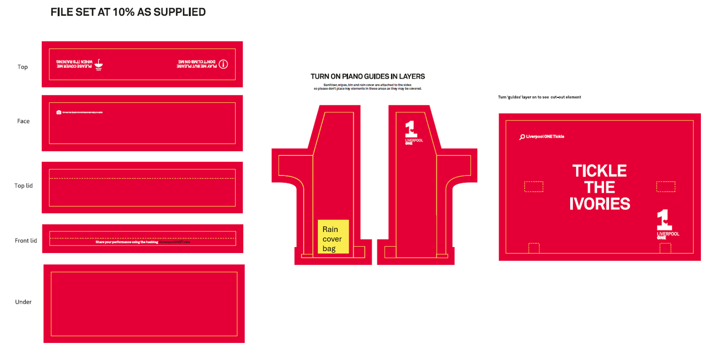

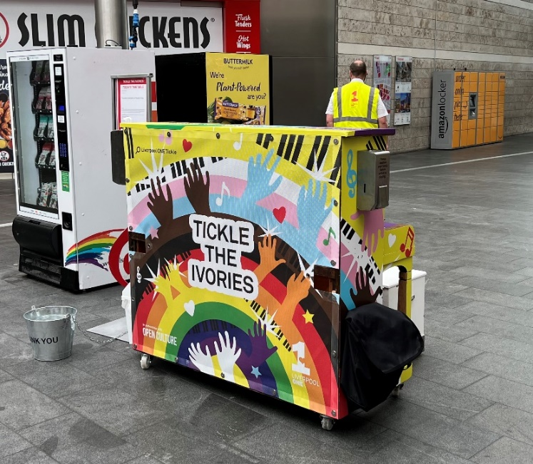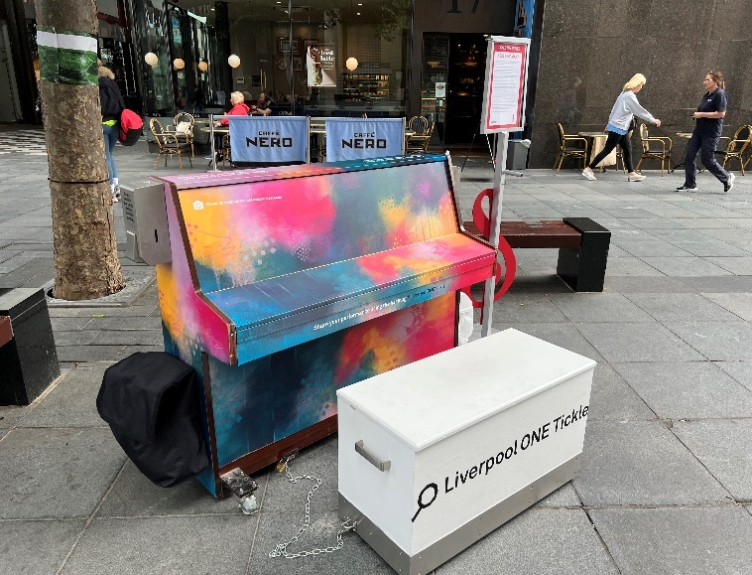
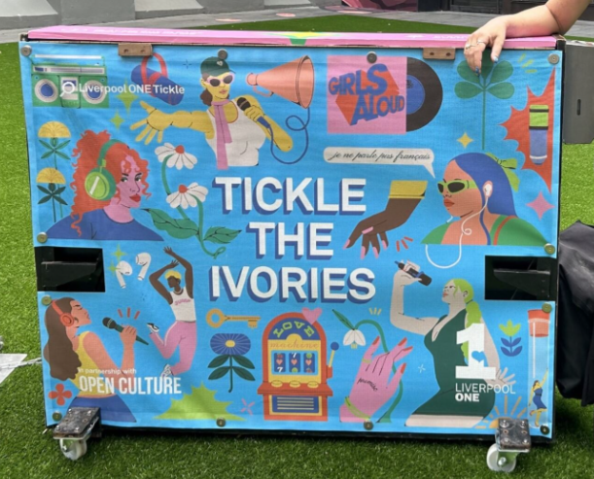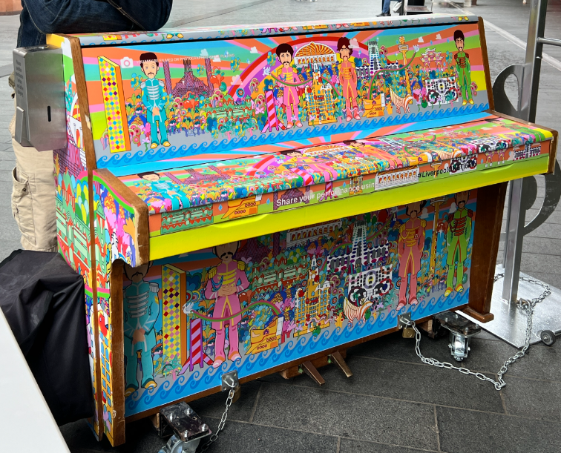

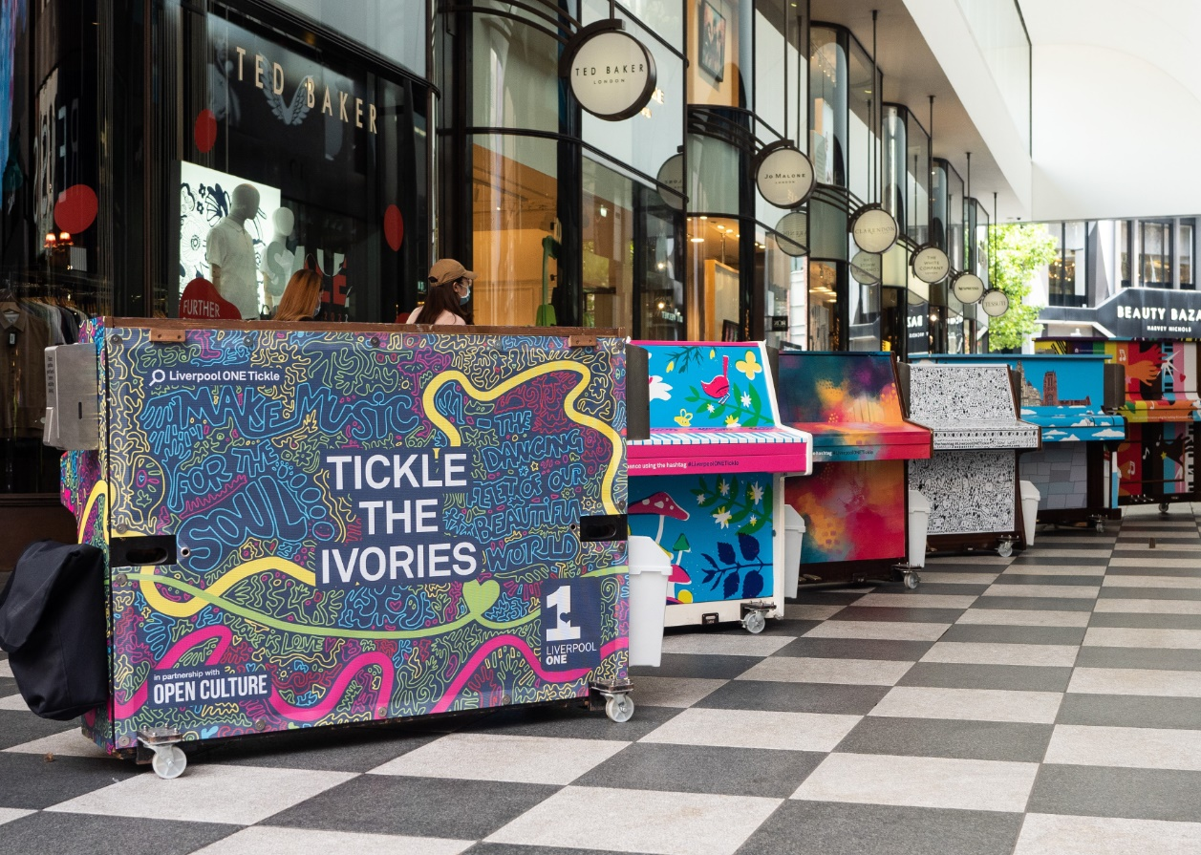

Thank you

